23CSE111 OBJECT ORIENTED PROGRAMMING
S2 B.Tech CSE
Department of Computer Science and Engineering
Amrita School of Computing, Amritapuri Campus
CASE STUDY
PHASE – 2 (Design)
Architectural Modelling (CO2)

Group No : C-2
Team Members :
Roll No | Student Name
AM.SC.U4CSE25221 | HarinandhReddy Areti
AM.SC.U4CSE25211 | Nitesh
AM.SC.U4CSE25223 | Ganesh
AM.SC.U4CSE25255 | Vardhan
AM.SC.U4CSE25241 | Charan Raj

- Problem Title : Railway Reservation System

STRUCTURAL DESIGN
- Class diagram (draw class diagram that shows different classes and their relationships. Use UML notations)

uml diagram
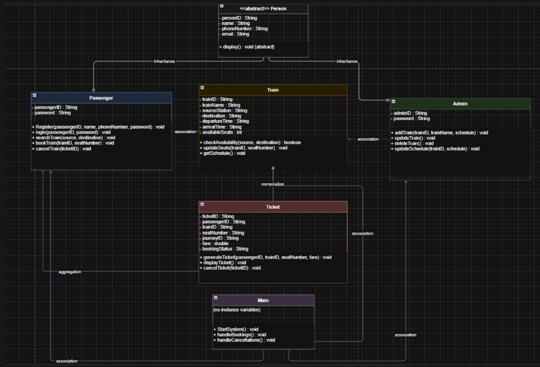

BEHAVIUORAL DESIGN
- Use-case diagram
- List of actors
1. Passenger
- Admin
- List of use-cases
- Passenger
Register → creates new account
Login → logs into system
Search Train → checks available trains
Book Train → reserves seat
Cancel Ticket → cancels booking
- Admin
Add Train → adds train data
Update Train → modifies train info
Delete Train → removes train
Update Schedule → edits timings
- Use case diagram (use UML notations)

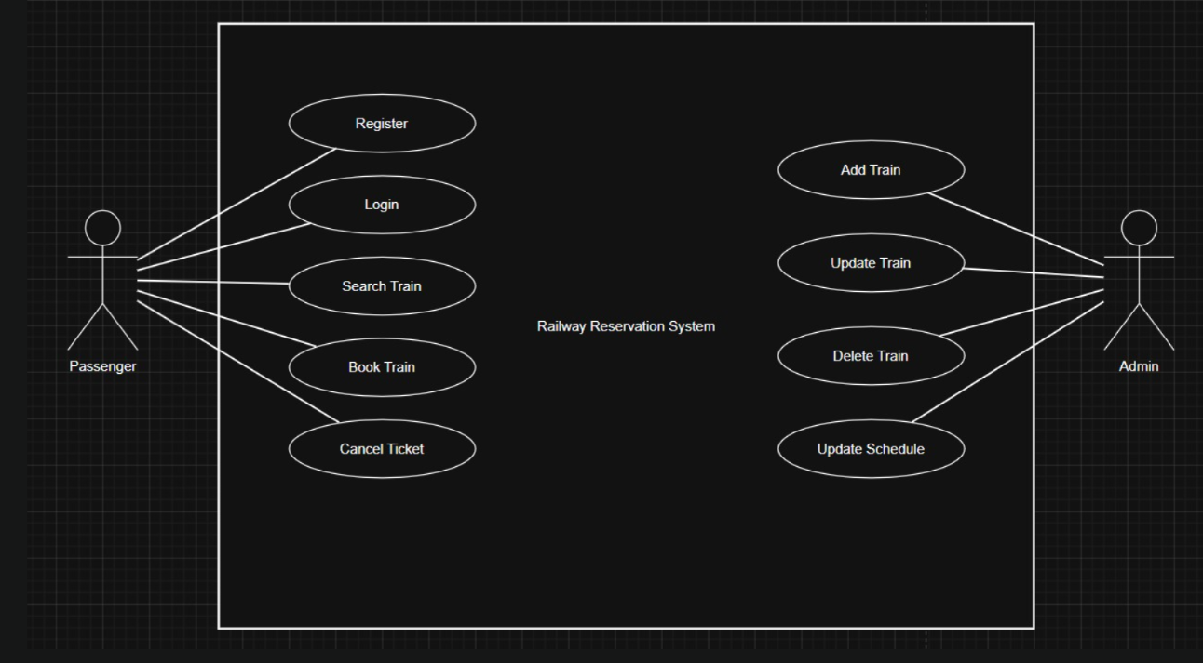

4. Brief Explanation of the Design
This sequence diagram explains the railway reservation workflow where a passenger registers, logs in, searches for trains, books a seat, receives a ticket, and can later cancel it. It also includes admin operations such as adding trains and updating schedules.

Sequence diagram
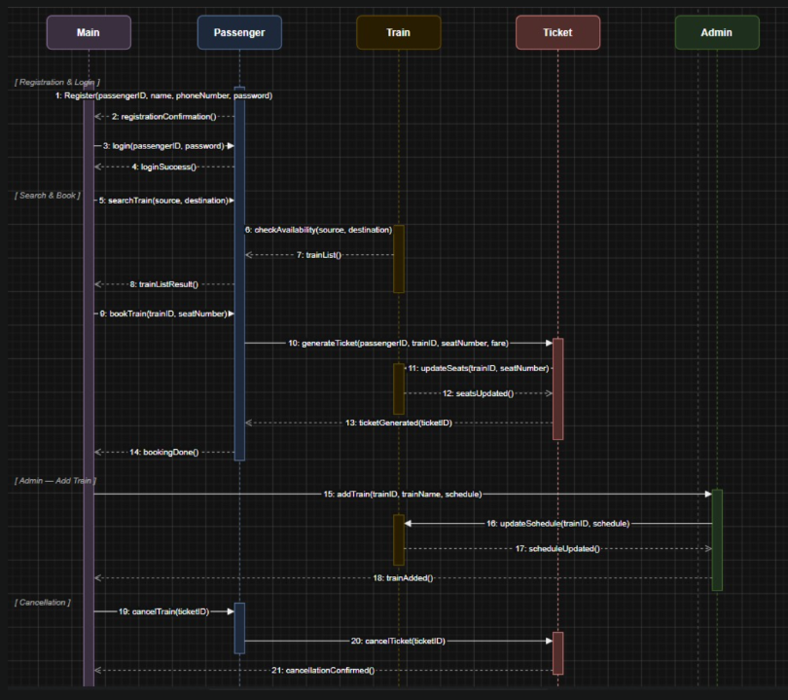
Relationships used (association / aggregation / inheritance)
Key interaction flow captured in the sequence diagram:
Major Classes Identified and Their Responsibilities.Person (abstract): Base class for all user-related entities. It stores common details such as personID, name, phoneNumber, and email, and includes an abstract method display().

Passenger: Inherits from Person. Represents a passenger with additional properties such as passengerID and password. It is responsible for registration, login, searching trains, booking tickets, and cancellation.
Admin: Inherits from Person. Represents the railway administrator who manages train-related operations like adding trains, updating train information, deleting trains, and updating schedules.
Train: Represents a train, defined by trainID, trainName, source station, destination, departure time, arrival time, and available seats. It handles availability checking, seat updates, and schedule retrieval.
Ticket: Represents the ticket generated after successful booking. It stores details such as ticketID, passengerID, trainID, seat number, fare, journey ID, and booking status.
Main: Initiates the application flow and coordinates the overall railway reservation process, including booking and cancellation handling.
Relationships Used:
Inheritance: Passenger and Admin inherit from Person.
Association: Passenger is associated with Train; Admin is associated with Train; Main is associated with Passenger, Admin, and Train.
Aggregation: Passenger aggregates Ticket, since one passenger can hold multiple tickets.
Composition: Train composes Ticket, because a ticket is strongly dependent on the selected train.
Key Interaction Flow Captured in the Sequence Diagram:
The Main object starts the railway reservation system using StartSystem().
The Passenger first performs Register(passengerID, name, phoneNumber, password) and then logs in using login(passengerID, password).
The Passenger searches for trains using searchTrain(source, destination), which interacts with the Train object through checkAvailability(source, destination).
After available trains are displayed, the passenger books a train using bookTrain(trainID, seatNumber).
The Ticket object then generates a ticket through generateTicket(passengerID, trainID, seatNumber, fare), while the Train updates seat count using updateSeats(trainID, seatNumber).
The Admin can also add trains using addTrain(trainID, trainName, schedule) and modify schedules through updateSchedule(trainID, schedule).
During cancellation, the passenger invokes cancelTrain(ticketID), which internally triggers cancelTicket(ticketID) in the Ticket class.
Finally, the system confirms booking or cancellation completion through the Main control flow.

